**Assignment 9**

**Advance Programming Lab**

**Question 1: Number of Islands**

**Output:** 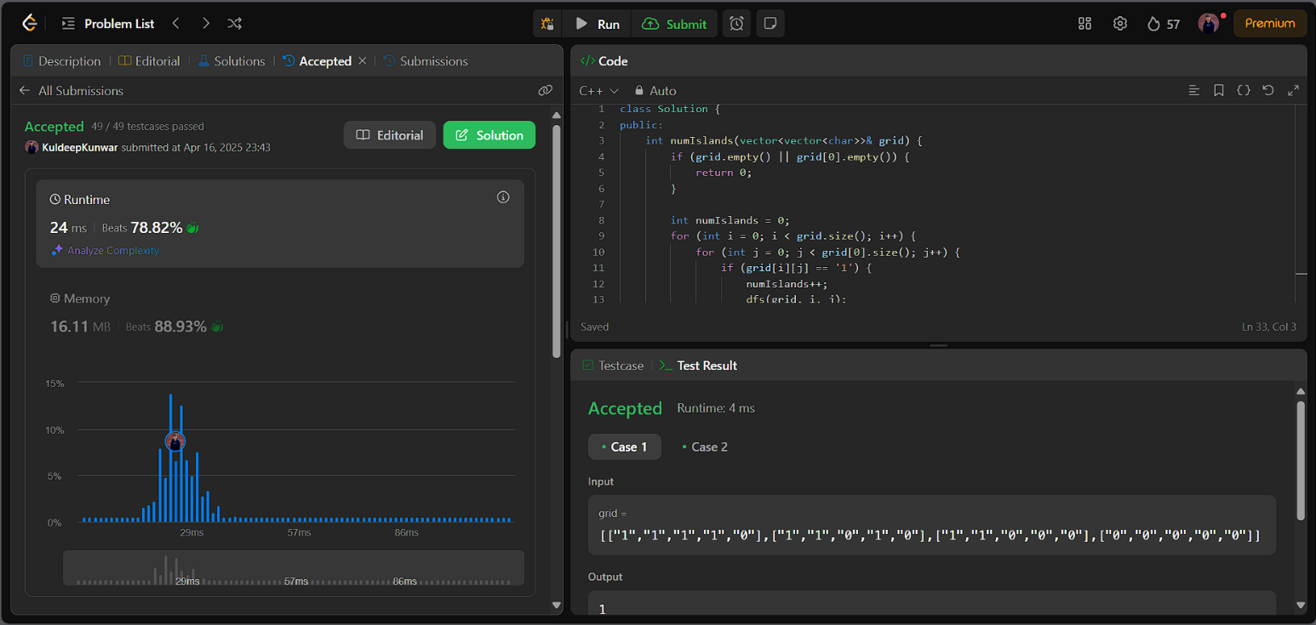

**Question 2: Word Ladder**

**

**Question 3: Surrounded Regions**

**

**Question 4: Binary Tree Maximum Path Sum**

**

**Question 5: Friend Circles**

**Output:** 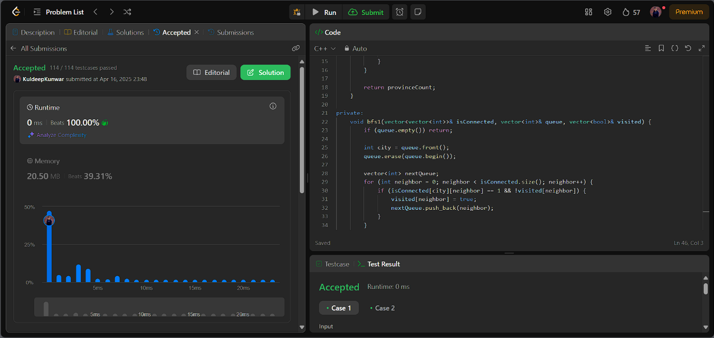

**Question 6: Lowest Common Ancestor of a Binary Tree**

**Output:** 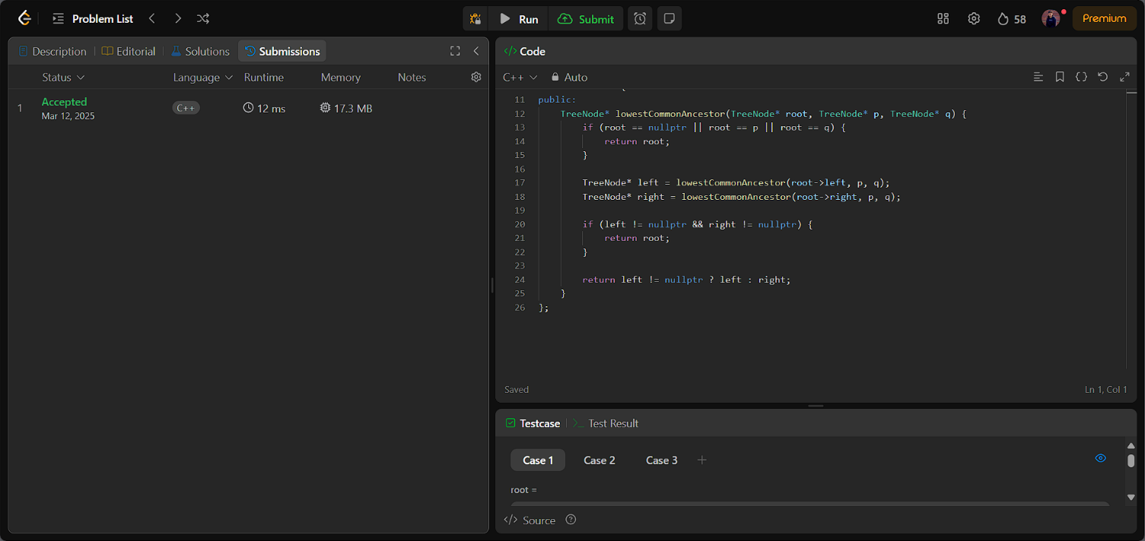

**Question 7: Course Schedule**

**

**Question 8: Longest Increasing Path in a Matrix**

**